**Question 8**

The Benefits of Using Anchor Boxes:

Anchor boxes aid in the better localization of items within an image. They direct the object detection model to focus on specific sections of an image where objects are expected to be present by specifying specified shapes and sizes.

Handling Multiple Object Sizes: The sizes of objects in photos might vary greatly. Anchor boxes enable the model to effectively recognize and forecast items of varying sizes within the same image.

Better Generalization: Anchor boxes assist the model in generalizing to a variety of object sizes and aspect ratios. This increases the model's ability to detect items in a variety of situations.

Reduced Computational Complexity: Instead of considering all possible bounding box shapes and sizes, anchor boxes limit the choices, reducing the computational complexity of object detection models.

Determining the size of the anchor box

The most common method for determining anchor box sizes is K-means clustering. You choose a value for K, which corresponds to the number of anchor boxes you want to define. In this case, K would be 5 since we have 10 values for height and width (5 anchor boxes).

**Question 10**

I have chosen 0103.jpg and 0104.jpg

In the image 0103.jpg the algorithm has only detected the bus and failed to detect the car, traffic light and the truck. In the 0104.jpg algorithm could only detect the traffic light and the truck, but fails to detect the cars in the left side of the image.

Input images

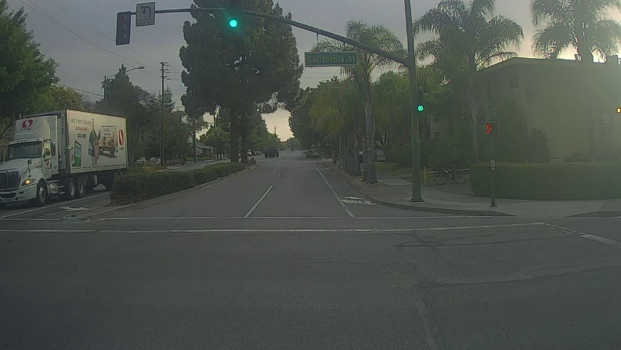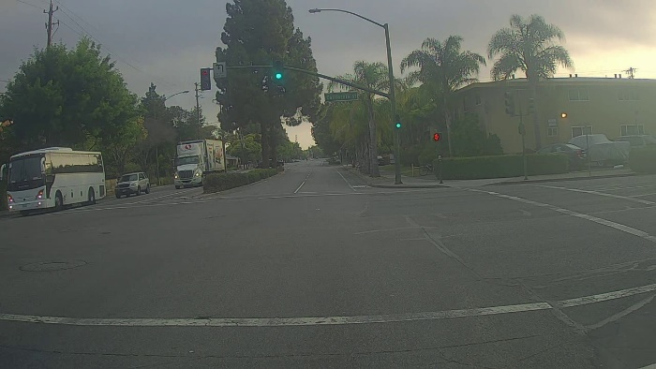

Output images

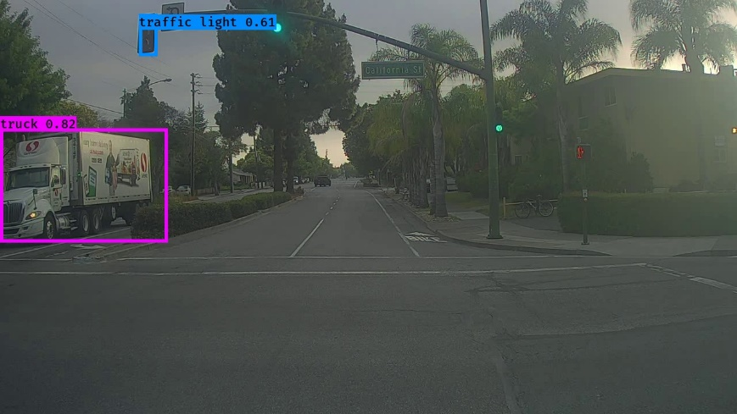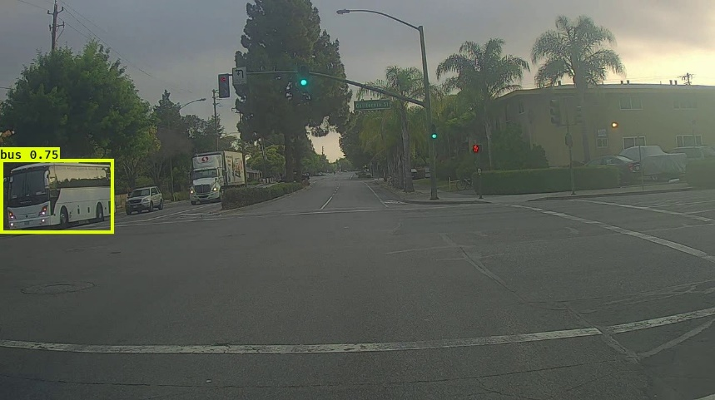

After changing the max_boxes, score_threshold, iou_threshold = 12, 0.8, 0.6 the algorithm could not detect any objects. However, for my input image it was able to detect the 4 car objects.

